# Title: Simple Interest Calculator using HTML CSS and JavaScript

Description:

Simple Interest is the term used to describe the rate at which money is borrowed or lent. **Simple Interest Calculator** serves as a practical tool for computing interest on loans or savings without compounding. It allows you to determine the simple interest on the principal amount, offering flexibility in calculating daily, monthly, or yearly interest. In this article, we will create a simple yet effective Simple Interest calculator using HTML, CSS, and JavaScript.

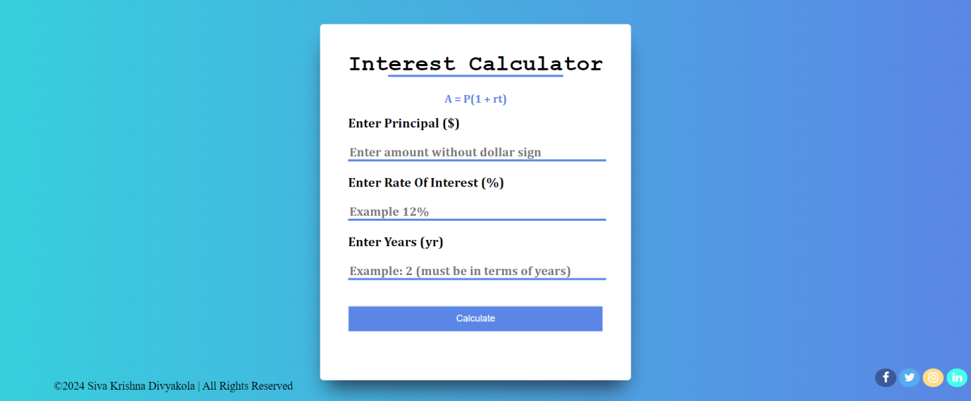

Source Code Link:

https://github.com/divyakola/Simple-Intrest-Calculator-with-HTML-CSS-Javascript